**Lab Sheet 02**

**TG/2021/1057**

Create Static Web App

GitHub Repo:

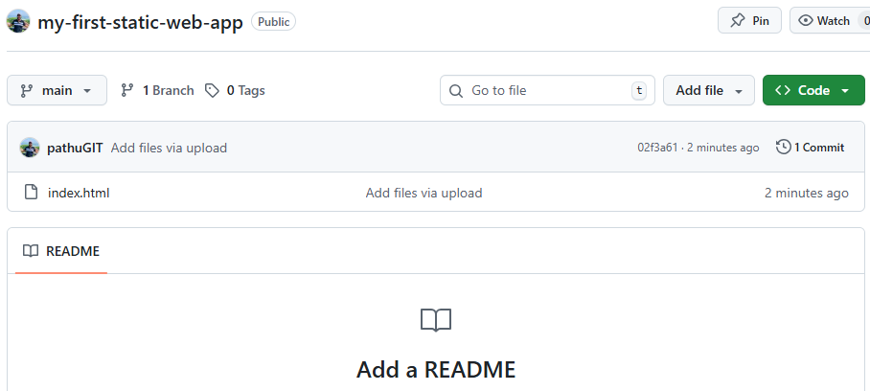

Azure Static WebApp  
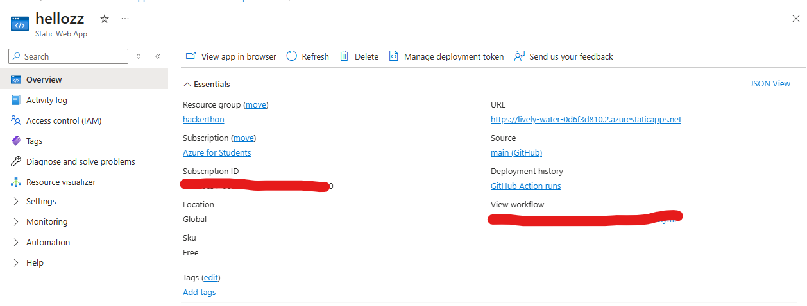

Output:

<https://lively-water-0d6f3d810.2.azurestaticapps.net/>

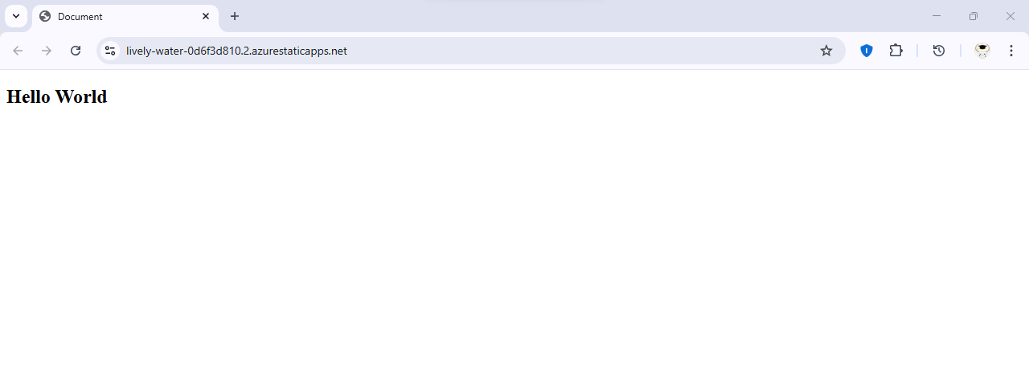

Create PHP WebApp